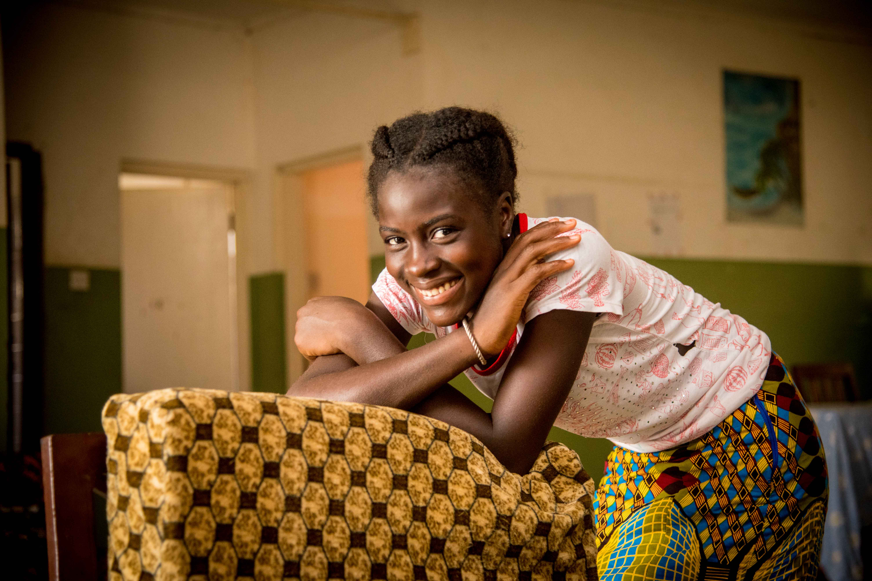

November 2021

Press Pack 40th Anniversary SOS Children’s Villages in The Gambia

Press Pack

Summary

1 Press release 3

2 About SOS Children’s Villages in The Gambia 5

3 Success Story 8

4 Rundown of Events 9

5 Our Partners 11

**SOS Children's Villages in The Gambia Celebrates 40 years of Service to Vulnerable Children in The Gambia**

40 Years Celebration

As a child, you need someone who truly sees you – who stands by you no matter what. Someone who holds you close when you are small and believes in you when you are ready to grow into your own and step into the world. Today, 1 in 10 children and young people are separated from their families, abandoned, neglected, or forced to live in an abusive environment, growing up without the support they need to prepare themselves for their future. **We exist to change this**

It was against this background that in 1982, SOS Children's Villages in The Gambia opened the first Children's Village in Bakoteh with 6 family houses to care for children who have lost parental care and those at risk. Since its inception, the organization continues to operate and implement a series of programs, from alternative, family strengthening, education programs, youth empowerment projects, women and community empowerment projects, and many more to ensure that No Child Should Grow Up Alone in The Gambia.

**This year we are marking 40 years of service ( March 1982 – 2022 ) to the plight of vulnerable children, young people, and women in The Gambia. Our 40 years of experience show that when children in our target group are able to thrive, they are more likely to contribute positively to their communities and, if they have children, to be good parents themselves.**

In this way, the work made possible by the organization, Government of The Gambia, donors, and partners not only impacts hundreds of thousands of children and young people today but also helps to ensure a brighter future for generations to come.

**OBJECTIVE OF THE CELEBRATION**

There are three main objectives of the celebration of SOS Children’s Villages in The Gambia .at 40 years.

* To promote and highlight SOS Children’s Village's work in The Gambia for the past 40 years
* Fundraise for our programs
* Increase sponsors and corporate donors

**EXPECTED OUTCOMES:**

* SOS Children’s Village's work in The Gambia is appreciated and recognized, especially our impact.
* The National Association was able to raise a significant amount of money for our programs
* Increased the number of corporate, partners, and sponsors
* Organization visibility is increased (public, partners, etc, know more about what we do and why).

For SOS Children's Villages, ensuring the rights of children and young people is an essential part of its work. The organization is committed to working to create and maintain a caring and nurturing environment for them so that they can enjoy their childhood and contribute to the development of their communities.

**CONTACT**

**Almami Barrow**  – Communications and Advocacy Coordinator -SOS Children’s Villages in The Gambia – [almami.barrow@sosgambia.org](mailto:almami.barrow@sosgambia.org) – (+220) 7662982

**Jean-Pierre Kouamin**  – National Director of SOS Children’s Villages in The Gambia – [jeanpierre.kouamin@sosgambia.org](mailto:jeanpierre.kouamin@sosgambia.org) – (+220) 2706941

About us

**SOS Children’s Villages in The Gambia –** [www.sosgambia.org](http://www.sosgambia.org)

SOS Children’s Villages in The Gambia is a non -profit organisation with two main locations in Bakoteh and Basse.

Since its existence in 1982, Over the past 40 years, SOS Gambia runs programs on alternative care, family and community strengthening programs, education, and health care. During these 40 years, with its growing concern for vulnerable communities and its orientation of service to alleviate poverty and support the government in meeting its socio-economic development agenda of Vision 2020 and the MDGs, SOS Children's Villages The Gambia supported various communities with their identified needs and during emergencies.

**1982- 2007**

From 1982 to 2007, we operated 5 projects and programs. From 2007 to date our programs and projects increased to 20 to cater for more vulnerable

**2007-2022**

(2 Children’s Villages and 2 Kindergartens, 1Training and Production Center, 1Regional Mother and Adult Training Center, 1 Clinic 1 Educational Facilities 7, 2 Child Rights Projects, 2 Youth Empowerment Projects, 1 Nutrition Project, 5 Family and Community Empowerment Projects, external funded projects 2 and Youth Facilities 2.

**Throughout these 40 years, SOS Children’s Villages The Gambia has set up the following social service and developmental programs;**

**From 1982 to 2007**

* **1994,** In celebration of the International Year of the Family, the following projects were offered to the community: The construction of an Islamic School at Jambanjelly.The construction of a Well at Janwely (Western Region).The construction of a House for a very needy family at Sanchaba Suley Jobe.
* **1999** the construction of three low-cost houses for three very needy families. The project was called “Children Helping Children” in celebration of 50 Years of SOS Children’s Village International. Assisted in kind to the Royal Victoria Campama Mental Hospital.
* **1999-2000,** the complete refurbishment of the Bakoteh Proper Lower Basic School with the extension of sanitation facilities and a sports field (*This school initially was built by SOS Children’s Villages and handed over to the Ministry of Education).*, and the construction of the bridge between Manjai Kunda and Dippa Kunda so that children can safely cross to go to school.
* **2001-2005**, major participation was in the building of the Kololi Health Clinic**.** Emergency relief assistance was offered to the Basse flood victims. The construction of the Bakoteh Community Social Centre was handed over to the community. The construction of the Bakoteh Shelter for Street Children was handed over to the Department of Social Welfareand the construction of the Bajagarr Community Social Centre which was handed over to the community and supported by NGO Affairs Agency with IT equipment and a vehicle; Tango with equipment, and the Airport Immigration office with IT equipment

**2007-2022. Through funding, we were able to implement the following**

1. Constructed school sanitary facilities for  **3** schools in the Central River Region through an EU Funded Project on Child Rights to improve sanitary hygiene with an indirect reach of 400,000 people.
2. A Strengthening the Economic Resilience of Vulnerable Youths in The Gambia Project. Through support from SOS Children’s Villages Finland, we were able to increase the social and economic resilience of **600** aged **15** to **35** vulnerable youths in LRR and CRR of the Gambia, providing them with market-driven technical skills/post-secondary education.
3. A Women Empowerment Change 3 years project. The Project strengthen and build the capacities of **200** vulnerable women in 3 communities in Farafenni to take care of themselves and the survival and development needs of their children.
4. A Family Strengthening Bansang Project has supported **1,000** children in **310** families in **5** communities.
5. Through our EU-Funded project on Sustainable Nutrition Improvement Project, we have contributed to the nutritional improvement of children at risk of losing care. Supported **450** women farmers, **525** students, and **900** vulnerable farmers. The overall all objective was to contribute to improved nutrition of children at the status of **1875** in **4** communities in Basse, supported a Family Strengthening Programme that caters to children at risk of losing parental care when care is given within their family and their caregivers are supported with an income-generating activity to allow them to be self-sustaining and take care of the needs of their families.
6. A Family Strengthening Programme in Basse has supported **750** children and **227** families in **5** communities. A Community Empowerment Project which has supported **71 care givers**  and **150** children to contribute to the empowerment of women (single-headed households) and the promotion of women and children’s rights in  **3** communities in Basse. A Family Strengthening Programme that caters to children at risk of losing parental care when care is given within their family and their caregivers are supported with an Income Generating Activity to allow them to be self-sustaining and take care of the needs of their families.
7. A Family Strengthening Programme Bakoteh since its inception supported **1761** beneficiaries, **150** caregivers, and **376** children in **9** communities in the Kanifing Municipal Council.

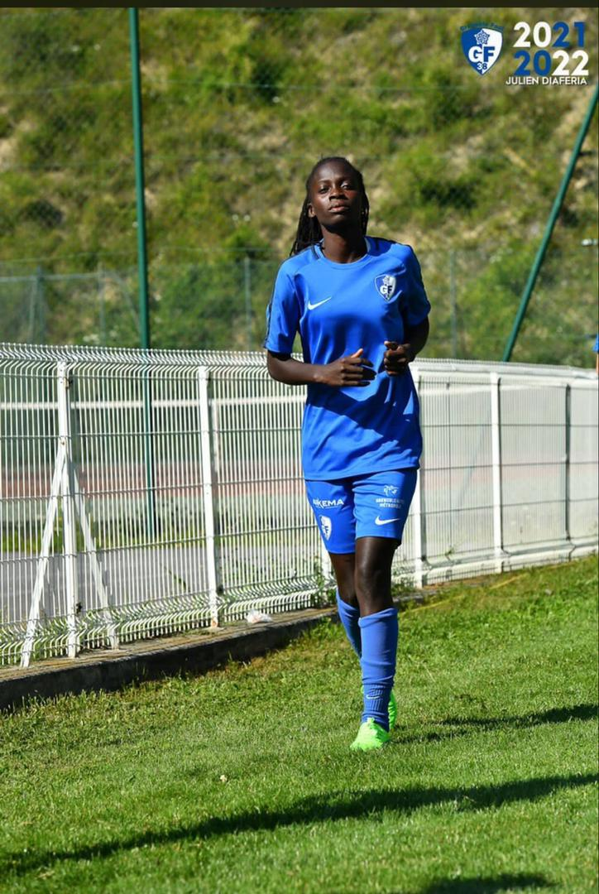**“I have always dreamed of becoming a footballer”**

As far back as she can remember, Adama has always loved playing football and dreamed of becoming a professional footballer. A dream that came true at the age of 22. Indeed, Adama moved to France in 2021 after she signed a contract with the team Grenoble where she is currently playing.

During her stay at the SOS Children’s Village Bakoteh, Adama loved discussing football with her twin sister, also a football player, and other siblings in her house during her free time.

“Hearing my brothers and sisters calling us The Gambia's finest baller makes us happy,” remembers Awa, Adama’s twin. Adama pushes hard for her to achieve her dream. Every afternoon, after finishing school, she goes for training at a local stadium. She later joined a local football club where she played for some years.

At the football club, she performed very well, which allowed her to be spotted by the Gambian Football Federation and to join the national women’s football team. And what a feat: she has won several trophies, such as the best female footballer of the year in four 4 consecutive years. Adama and her twin sister Awa, also a member of the team, led the Gambian Women’s National team to the FIFA under-20 tournament in Azerbaijan and other international and regional tournaments.

​​​​​In 2022, Adama will be playing for The Gambia in the qualifier round for the women’s world cup. Both Adama and Awa are hoping to get The Gambia to qualify for the tournament.

Adama and her sister Awa, cannot yet live on their soccer income. They, therefore, had the idea, together with their brother Bakary, to engage in catering and are currently running the canteen at the SOS Hermann Gmeiner Technical Senior Secondary School in Bakoteh, serving meals to some over 200 students.

Like any parent, we don’t believe that a relationship ends with a child on their 18th birthday. We stand by young people in their transition to adulthood. SOS Children’s Villages attaches great importance to ensuring that the young people entrusted to its care are well prepared for the social and economic realities of their world and are empowered to develop their perspectives in life.

Event Rundown

**29th of November 2022 Open Day**

Where key stakeholders will have a first-hand experience in learning more about SOS Children’s Villages work in In The Gambia and interact with staff and participants

Guest of honor **His Excellency President of the Republic of The Gambia**

**3rd, of December 2022 March Past**

The march past will commence from the Traffic Light to the SOS Children’s Village in Bakoteh. This will be followed by an evening event for our staff and participants

**10th of December 2022, Fundraising Gala Dinner**

The climax of the celebration is a Fundraising Gala Dinner which will be held on Saturday 10th December 2022 at Kairaba Beach Hotel.**First Lady of the Republic of The Gambia is the Chief Guest of Honour**

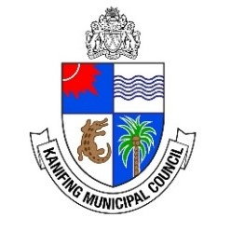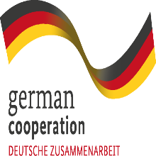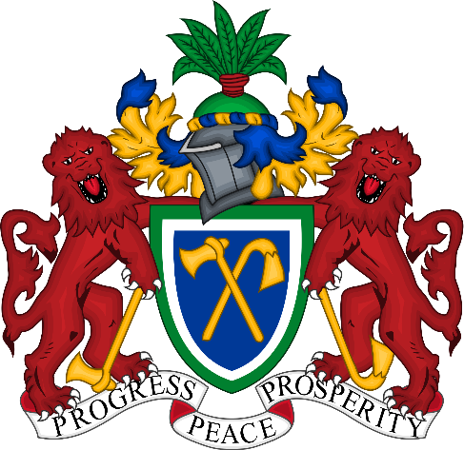

Our Partners



